Wilderness North Group Hackathon Challenge
Challenge sponsor | Zamiigo (Wilderness North Group)

ABOUT WILDERNESS NORTH
Wilderness North has operated in Northwestern Ontario for thirty years and runs the largest collection of fly-in lodges and outpost cabins in the region. In 2019 it bought a Nakina-based airline that flies Cessna 208 Caravans on charter and freight runs into remote First Nation communities such as Webequie, Neskantaga and Summer Beaver. With support from the Northwestern Ontario Innovation Centre, it developed Zamiigo, an online grocery platform that improves access to groceries in those communities and currently serves Webequie. Customers place their own orders in the Zamiigo app. Wilderness North combines them and submits one batch order through the consumer portal of a major retailer such as Real Canadian Superstore, so a single order at the store can hold 20 to 30 or more household orders. Store staff pick the items and pack them into Zamiigo's returnable totes, the totes fly out of Nakina, the Nutrition North Canada subsidy is applied to the eligible products in each household's order, and a local partner handles door-to-door drop-off and brings the totes back.

THE WHY

Zamiigo lowers the delivered cost of groceries by passing the Nutrition North subsidy straight to each household and by keeping the aircraft full. Retailers will not open their systems to outside integrations, so every order goes through their consumer platform, which is built around one household and one account. Staff re-create each Zamiigo order by hand in the retailer's system, which is the largest source of manual work today and grows with every new customer. Each customer's order, substitutions, pricing and receipt must stay separate, because the subsidy applies to eligible products in each household's order. In the store, each customer usually gets their own tote, which wastes aircraft space when a household orders only a few items. Wilderness North wants a fulfillment layer that sits between Zamiigo and the retailer and needs no changes to the retailer's e-commerce system.

THE CHALLENGE

Wilderness North is asking for one application with three tabs that carries Zamiigo orders from the retailer's ordering system to the aircraft. The order entry tab prepares each customer's order for the retailer's platform and tracks its status from entry to picking. The order picking tab groups household orders into shared totes, keeps each order separately bagged and labelled, and gives the picker a cart-by-cart pick list. The flight management tab loads those totes onto the aircraft and reports the weight and space left on every flight. The tote carries through the whole chain, so the grouping that saves the picker a trip also sets how many totes fly and what they weigh. The system optimizes for fewest totes, most complete orders per tote, least picking work and full use of the aircraft.

TECHNICAL PROBLEM DESCRIPTION
You will be given a dataset of grocery orders. Your system needs to work through the following steps at every stage of the challenge.
1. Enter and track the orders. Take the orders capture and produce, for each customer, an order entry ready for the retailer's online ordering system, with a status that can be tracked from entered to picked. Teams will not connect to a real retailer site.
2. Group orders into totes. Take all orders headed to Webequie and decide which ones share a tote. Two or more orders can go in one tote if their combined weight and volume fit inside it. An order too large for one tote is split across several. Aim for the minimum number of totes and the maximum number of complete orders per tote.
3. Load the carts and build the pick list. A picker walks the store with one cart holding a set number of totes, five by default and configurable to match the store. Assign the totes to carts, keeping every tote for a given order on the same cart. For each cart, produce the item list grouped by tote and then by household order, in a form that can be printed or shown on a handheld scanner, so the picker works tote by tote and never makes two trips for the same item when one would do.
4. Sum the weight. Every tote gets a total weight and a fill percentage by volume. The tote weights calculated in the order picking tab are what the flight management tab uses for load planning, so both tabs work from the same batch of orders and the same totes.
5. Plan the flight load. Assign totes to the aircraft. For each flight, confirm the load fits within the payload the Caravan can carry to Webequie and within the cargo space available. Report the weight and the dimensional space left over on every flight.
6. Produce the manifests. For each flight, list the totes on board, the orders each tote contains, the total weight and the space used. The retailer, the driver and the pilot each need to be able to check the plan from this output.

INPUT AND DATASET
You will receive a CSV of grocery orders representing one batch submitted to a retailer, where each row is an item that needs to be delivered. Expect columns along the lines of order ID, household ID, item name, weight, dimensions, order date and destination community. Exact column names will be confirmed in the dataset provided at the start of the event. Orders vary in size, and some will be too large for a single tote.
During judging, teams will be given a fresh set of orders to run through the app, so the packing and load logic must generalize beyond the sample data.
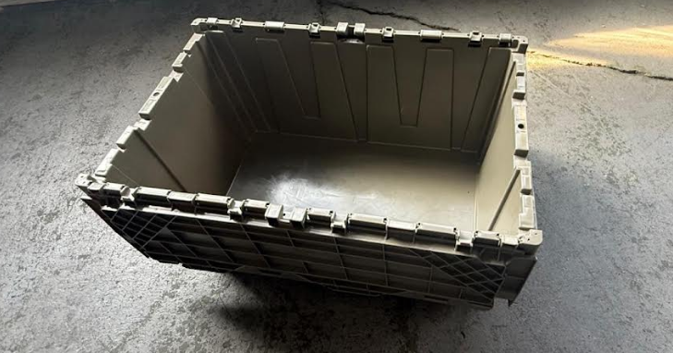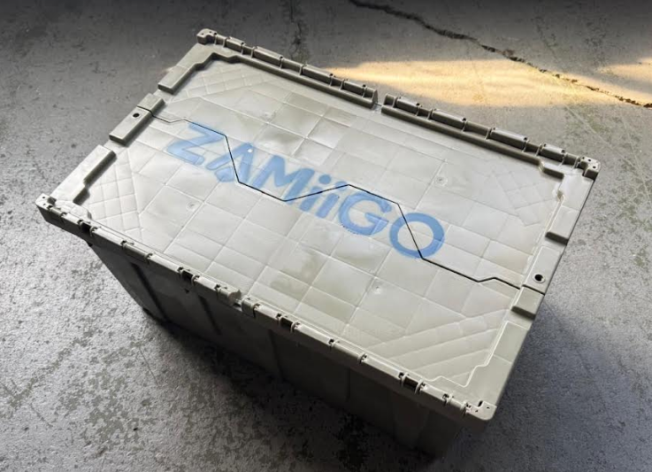
Zmiigo Toat

CONSTRAINTS AND REFERENCE DATA

The tote
• Internal dimensions are 23.5 inches long, 14 inches wide and 11 inches deep. The tote tapers to 25 inches long and 15.5 inches wide at the top rim.
• Treating the tote as straight-walled at the internal base dimensions is acceptable. That gives a working volume of roughly 3,600 cubic inches, or about 2.1 cubic feet, per tote.
• Photos of the tote are included with the dataset, and more can be provided on request.

The aircraft
• The challenge uses one Cessna 208 Caravan, estimated to carry a maximum of 90 totes when fully configured for freight and the totes are stacked.
• The 90-tote figure already assumes a stacking arrangement. Part of your work is to model how totes stack in the cabin and to state how much dimensional space remains once your load is placed.
• Published cabin figures for the Caravan family are roughly 64 inches wide and 54 inches high, with a cabin length of about 12.5 feet on the 208 and about 4 feet longer on the 208B Grand Caravan, and a cargo door of roughly 50 by 49 inches. An optional belly cargo pod adds further volume. Teams are expected to look up the dimensions for the model Wilderness North flies and to show the figures they used.
• Model the aircraft as an empty freighter with no passenger seats installed.

Route and payload
Payload depends on distance, because fuel comes out of the weight the aircraft can lift. The Nakina to Webequie route (CYQN to CYWP) is 169 nautical miles one way, or 389 statute miles for the round trip, and takes an estimated 2.49 flight hours at an average of 170 mph. The low operational weight is 3,923 lb and the estimated fuel is 1,046 lb, which leaves an average potential payload of 2,877 lb. CYQN is Nakina and CYWP is Webequie.
At 2,877 pounds of payload and a 90-tote ceiling, the average tote can weigh only about 32 pounds before weight becomes the binding constraint rather than space. Your load planner needs to handle both limits and say which one is binding on each flight.

STAGES

Stage 1, the base case
• Thirty orders, one community (Webequie), one Cessna 208 Caravan with no passengers.
• All thirty orders fit on one flight. Prepare the retailer orders, pack them into the fewest totes, generate the pick list and the manifest, and report the remaining weight and space on the flight.

Stage 2, scaling up
• Roughly 120 orders placed across several days (18 to 45 orders per day), still headed for one community. Orders arrive in batches, and Wilderness North releases one load per batch once the departure is confirmed, sometimes with only part of the hold available. The available payload and cargo space for each departure are given in the dataset.
• The load planner chooses which orders travel on which departure so that each flight delivers the most orders it can, without exceeding that departure's available payload or space. Show the packing for each flight, the leftover weight and space, and which orders roll over to the next departure.

OUTPUT AND REQUIREMENTS
Your submission should be a single working, deployed application with three tabs. The order entry tab must prepare each Zamiigo order for the retailer's platform and track its status. The order picking tab must suggest which household orders share each tote, let store staff see and adjust that grouping, and give the picker a cart by cart item list organized by tote and household. The flight management tab loads those same totes onto the aircraft. At a minimum it needs to do the following.
Order entry tab
• Turn each order captured in Zamiigo into an order entry for the retailer's online ordering system, and track the status of every order.
Order picking tab
• Accept a CSV of grocery orders as input.
• Provide an interface that groups orders into shared totes and lets staff adjust the grouping, minimizing the number of totes and maximizing complete orders per tote, and split any order too large for one tote.
• Assign totes to picker carts with a configurable number of totes per cart, and generate a pick list for each cart organized by tote and household, in a form a picker can print or use on a handheld.
• Report the total weight and volume fill of every tote.
• Keep each customer's items separate within the batch, so every household's order can be traced from entry to delivery.
Flight management tab
• Assign totes to flights, confirm each load fits within the Webequie payload and the cargo space in the aircraft, and report the weight and dimensional space left over on every flight.
• Handle the Stage 2 volume, choosing which orders travel on which departure and showing what rolls over.
• Produce a manifest for each flight showing the totes on board, the orders in each tote, and the flight's total weight and space used.
• State the aircraft cabin dimensions and stacking assumptions used, with the source.
Whole application
• Be deployed online so judges can interact with it directly. Local-only demos will not be accepted.
Beyond these requirements, teams are free to add any additional features that improve the experience or usefulness of the tool. A scan-as-you-pick view for the handheld, a visual of the load layout in the cabin, or a cost-per-order figure for each flight would all be welcome.

